Task 11 Create Azure File Share

Step 1: Sign in to Azure Portal
- Open the browser.
- Go to Microsoft Azure Portal
- Login using your Azure account credentials.

Step 2: Create a Storage Account
Azure File Share is created inside a Storage Account, so first create one.
- In the top search bar, type Storage accounts.
- Click Storage accounts.
- Click + Create.
Fill the required details:
- Subscription: Azure for Students
- Resource Group: Create new (Example: task11)
- Storage Account Name: mytask11 (must be unique)
- Region: East Asia / any region
- Performance: Standard
- Redundancy: Locally Redundant Storage (LRS)
- Click Review + Create.
- Click Create.
⏳ Wait for deployment to complete.

Step 3: Open the Storage Account
- After deployment, click Go to Resource.
- The Storage Account Dashboard will open.
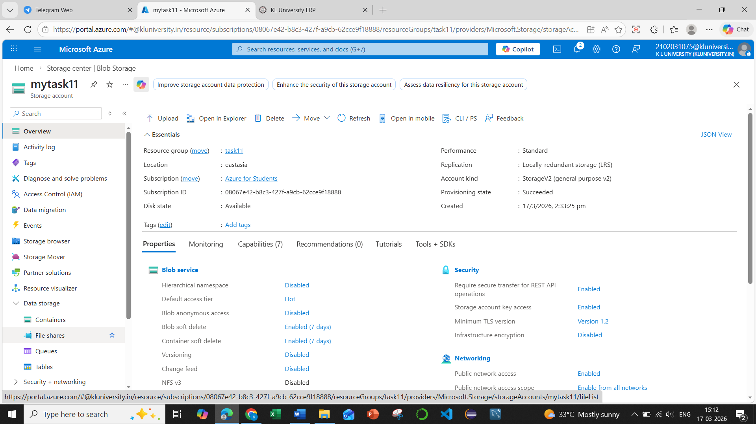

Step 4: Create Azure File Share
- In the left menu, go to:
Data Storage → File shares
- Click + File Share.
- Enter the details:
- Name: projectfiles
- Tier: Transaction Optimized
- Quota: Example 100 GiB (or default)
- Click Create.
✅ Your Azure File Share is now created.
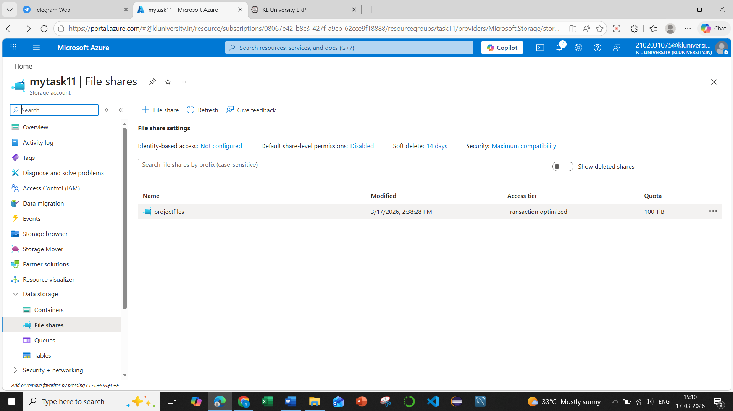

Step 5: Upload Files to the File Share
- Click the file share projectfiles.
- Click Upload from the top menu.
- Select a file from your computer.
- Click Upload.
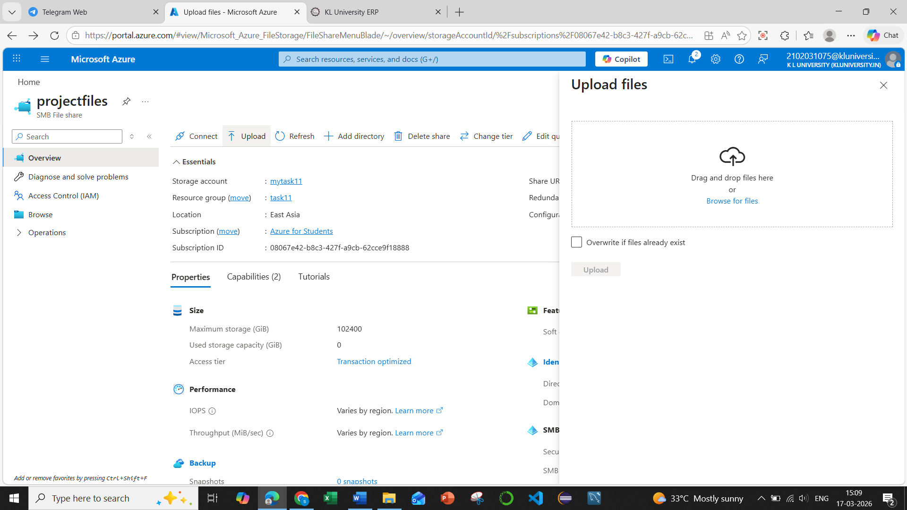
The file will now appear in Browse section.
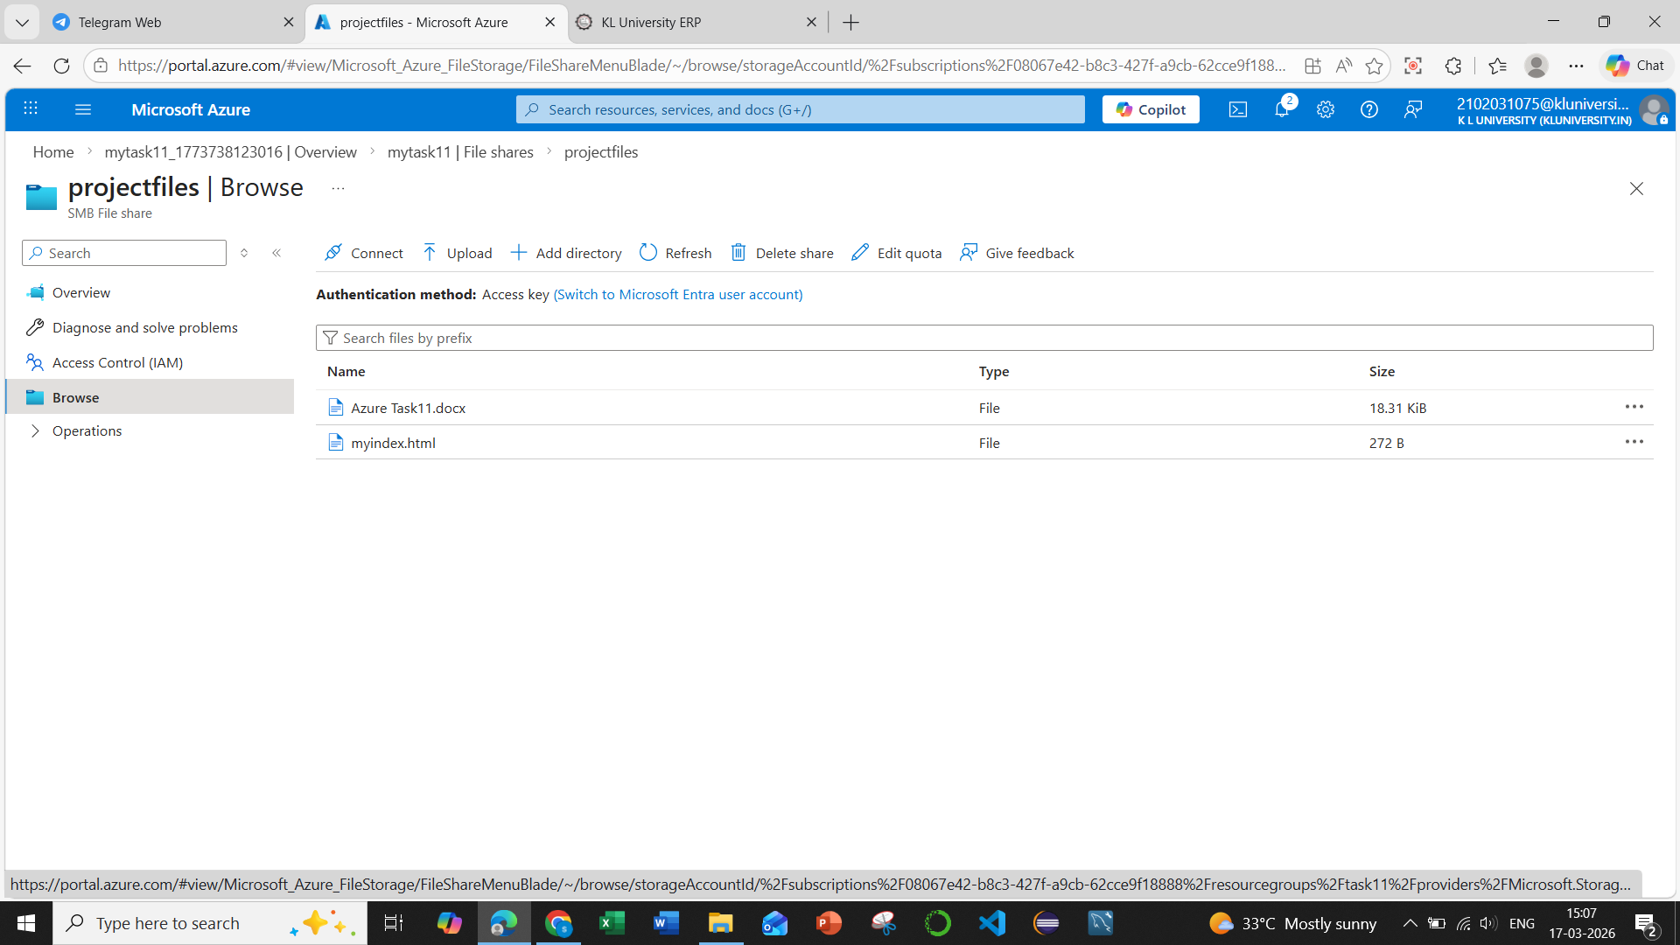
✅ Final Structure
Azure Portal
└── Storage Account (mytask11)
└── File Shares
└── projectfiles
└── Uploaded Files

